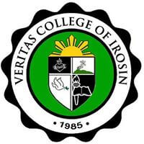**Veritas College of Irosin**

**San Julian, Irosin, Sorsogon**

**A.Y. 2023 - 2024**

**NSTP-LTS**

**Accomplishment Report**

**JULY 25, 2024**

**Veritas College of Irosin**

**San Julian, Irosin, Sorsogon**

**A.Y. 2023 - 2024**

**ENROLMENT**

**LIST**

**1ST – 2ND SEMESTER**

**(NSTP – LTS)**

**JULY 25, 2024**

**Veritas College of Irosin**

**San Julian, Irosin, Sorsogon**

**A.Y. 2023 – 2024**

**LIST OF**

**GRADUATES**

**NSTP - LTS**

**JULY 25, 2024**

**Veritas College of Irosin**

**San Julian, Irosin, Sorsogon**

**A.Y. 2023 – 2024**

**COURSE SYLLABUS**

**NSTP - LTS**

**JULY 25, 2024**